

East West University

Department of Computer Science & Engineering

**Course Title:** Database System

**Course Code:** CSE301  
**Experiment No:** 05

**Semester:** Fall, 2015

**Section:** 01

**Submitted By:**

S. M. Amirul Islam

ID: 2013-1-60-048

**Introduction**

We can add, delete or update information on database by using some commands.

# **Create the table employee.**

create table employee(

ename varchar(20),

street varchar(20),

city varchar(20)

)

Snapshot:



**#insert values in it:**

insert into employee(ename,street,city) values('Rahim','X','Dhaka');

insert into employee(ename,street,city) values('Mitu','Y','Sylhet');

insert into employee(ename,street,city) values('Sabbir','Z','Ctg');

insert into employee(ename,street,city) values('Babu','P','Dhaka');

insert into employee(ename,street,city) values('Toma','X','Bogra');

insert into employee(ename,street,city) values('Jabbar','X','Comilla');

Snapshot:

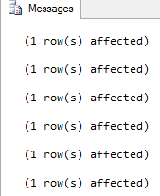

Output snapshot:

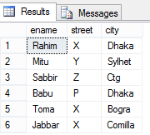

# **Create the table works:**

create table works (

ename varchar(20),

cname varchar(20),

salary int,

jdate datetime

)

**Snapshot:**



**#insert values in it:**

insert into works(ename,cname,salary,jdate) values('Rahim','First B.C',20000,'8/8/2008');

insert into works(ename,cname,salary,jdate) values('MItu','Small B.C',30000,'8/13/2008');

insert into works(ename,cname,salary,jdate) values('Sabbir','Square Pharma',40000,'9/17/2009');

insert into works(ename,cname,salary,jdate) values('Babu','GP',50000,'12/13/2009');

insert into works(ename,cname,salary,jdate) values('Toma','Square Pharma',35000,'10/10/2010');

insert into works(ename,cname,salary,jdate) values('Jabbar','First B.C',15000,'4/4/2009');

**Snapshot:**



Output snapshot:

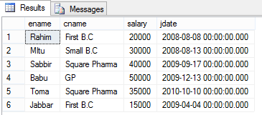

# **Create the table company:**

create table company(

cname varchar(20),

city varchar(20)

)

**Snapshot:**



**#insert values in it:**

insert into company values('First B.C','Dhaka');

insert into company values('Small B.C','Sylhet');

insert into company values('Square Pharma B.C','Ctg');

insert into company values('GP','Rajshahi');

**Snapshot:**

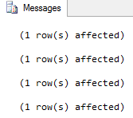

**Output Snapshot:**

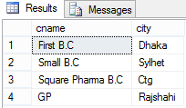

**# create the table manages:**

create table manages(

ename varchar(20),

mname varchar(20)

)

**Snapshot:**



**Insert values in it:**



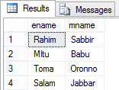

**Q1. Delete information of company which situated at Dhaka.**

**SQL:** delete from company where city='Dhaka'

select * from company

**Output:**



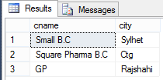

**Q2. Delete information from work table for the employee whose salary is less than 20000.**

**SQL:** delete from works where salary<20000

select * from works

**Output:**



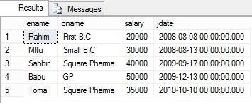

**Q3. Delete from employee whose street is x.**

**SQL:** delete from employee where street='X'

select * from employee

Output:



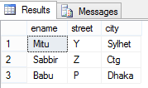

**Q4.Delete record from works that contains employee live in Rajshahi.**

**SQL:** delete from works where ename in(select ename from employee where city='Rajshahi')

select * from works

Output:



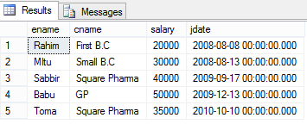

**Q5. Delete record from employee who works for ABC company.**

**SQL:** delete from employee where ename in(select ename from works where cname='ABC')

select * from employee

**Output:**



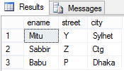

**Q6. Delete from works where manager names is Sabbir.**

**SQL:** delete from works where ename in(select ename from manages where mname='Sabbir')

select * from works

**Output:**



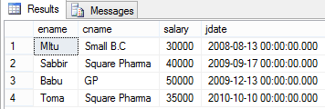

**Q7. Give all employee of First B.C Corporation are 10% salary raise.**

**SQL:** update works set salary = salary*1.1 where cname='First B.C'

select * from works

**Output:**

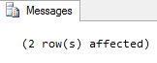

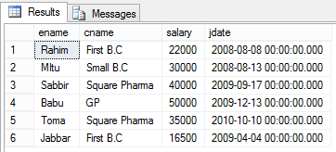

**Q8. Give all managers in the database a 10% salary raise.**

**SQL:** update works set salary=salary*1.1 where ename in(select distinct mname from manages)

select * from works

**Output:**



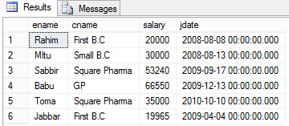

**Q9. Increase the salary of employee by 10% for the companies those are located Bogra.**

**SQL:** update works set salary=salary*1.1 where cname in(select cname from company where city='Bogra')

select * from works

**Output:**



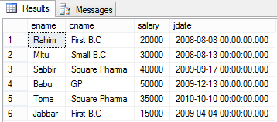

**Q10. Modify the DB so that Rahim now lives in Bhola.**

**SQL:** update employee set city ='Bhola' where ename ='Rahim'

Select * from employee

**Output:**



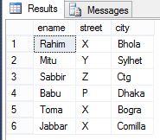

**Q11. Give all managers in this database a 10% of salary increase unless the salary after increment would be greater than 100000, in such cases give only a 3% raise of salary.**

**SQL:** update works set salary = case

when salary*1.1>100000 then salary*1.03

else salary*1.1

end

where ename in (select distinct mname from manages)

drop table works

select * from works

**Output:**

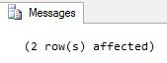

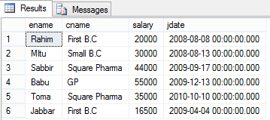

**Discussion:** In this lab we have learned how to update a database using database management system tools.